REPRODUCTION IN PLANTS
Short Answers
Ans (a)The transfer of pollen grains from the stamen to the stigma of a flower is called pollination.

Ans (b)The carrying away of seeds and fruits from the parent plant is called dispersal of seeds.

Ans (c)Advantages of vegetative propagation-
1) It is the fastest method of increasing the number of plants
2) Plants mature and bear fruits faster.
Disadvantages of vegetative propagation-
1) Plants lose their energy with time as there is no genetic variation
2) It often results in overcrowding .

Ans (d)Flowers that possess both the male and female reproductive organs are called bisexual flowers.
Ex-Tulip, lily
Flowers that possess either male or female reproductive organs are called unisexual flowers.
Ex-papaya ,watermelon
Long answers
Ans (a) Fertilisation-The process of fusion of male and female gametes leading to the formation of the zygote is called fertilisation.
When a pollen grain lands on the stigma of a flower,it produces a tube called pollen tube.The pollen tube carry the male gametes.
The pollen tube reaches the ovule and the male gamete fuses with the female gamete. The fused cell is called the zygote.
After fertilisation, the ovary develops into the fruit and the ovules change into seeds.
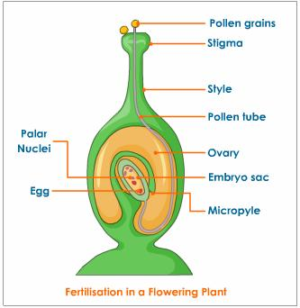

Ans(b)Grafting- Grafting is a method in which two stems of two different plants are joined together to grow as a single plant. In this method one stem is taken with root, called stock and other stem is taken without root, called scion.
The ends of the sock and scion obliquely cut and tied together firmly and planted into the soil..This give rise to a new variety of plant.
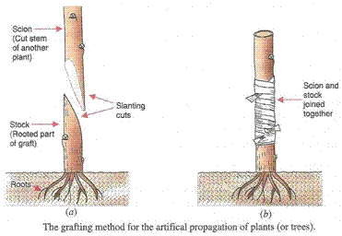
Ans (c)A flower has four whorls-sepals,petals,stamen and pistil
- Sepals: Sepal is the green-coloured part beneath the petals to protect rising buds.
- Petals: This is a bright-coloured part that attracts bees, insects, and birds. Colour of petals varies from plant to plant;
- Stamen: This is the male reproductive organ of the flower. It consists of two parts namely: anther and filaments.
- The anther is a yellowish, sac-like structure, which stores the pollen grains.
- The filament is a long thread like structure.
- Pistil or carpel: This is the innermost part and the female reproductive organ of a flower which comprises three parts -stigma, style and ovary.
- Stigma: It is the topmost part of carpel.
- Style: It is the long tube-like structure that connects stigma and the ovary.
- Ovary: The swollen part is called ovary. It is the part of the plant where the seed formation takes place.
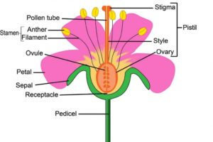
Ans(d) The carrying away of seeds and fruits from the parent plant is called dispersal of seeds.It is an essential process because it prevents overcrowding,avoids competition for water,light ,minerals and fecilitates spreading of plants to new area.
Distinguish between
Ans(a)
Sexual reproduction | Asexual reproduction
In this process, two parents are involved. | In this process, a single parent is involved.
Sexual reproduction involves the fusion of male and female gametes. | In asexual reproduction, plants can give rise to new plants without seeds.

Ans(b)
Self-Pollination | Cross-Pollination
Transfer pollen grains from the anther to the stigma of the same flower. | Transfer pollen grains from the anther to the stigma of a different flower.
This process can take place in the same flower or a different flower of the same plant. | This process can take place between two flowers present on different plants.

Ans(c)
Stamen | Carpel
Stamen is the third whorl of the flower | Carpel is the innermost whorl of the flower
It is the male reproductive organ of the flower | It is the female reproductive organ of the flower
It consists of two parts namely: anther and filaments. | It consists of three parts -stigma, style and ovary.

Ans (d)
Seeds dispersed by wind | Seeds dispersed by water
Seeds which are light and hairy are dispersed by wind | Seeds which are fibrous and can float on water are dispersed by water
Ex- maple, drumstick | Ex- coconut

